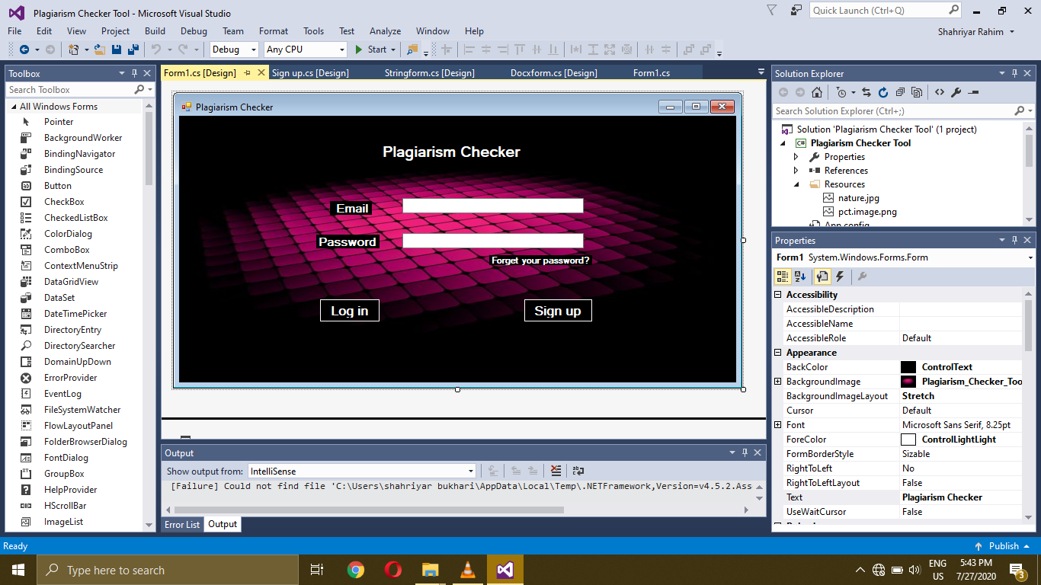

using System;

using System.Collections.Generic;

using System.ComponentModel;

using System.Data;

using System.Drawing;

using System.Linq;

using System.Text;

using System.Threading.Tasks;

using System.Windows.Forms;

namespace Plagiarism_Checker_Tool

{

public partial class Form1 : Form

{

public Form1()

{

InitializeComponent();

}

private void button2_Click(object sender, EventArgs e)

{

this.Hide();

Sign_up obj = new Sign_up();

obj.Show();

}

private void Form1_Load(object sender, EventArgs e)

{

}

private void Login_btn_Click(object sender, EventArgs e)

{

this.Hide();

Plagform obj = new Plagform();

obj.Show();

}

}

}

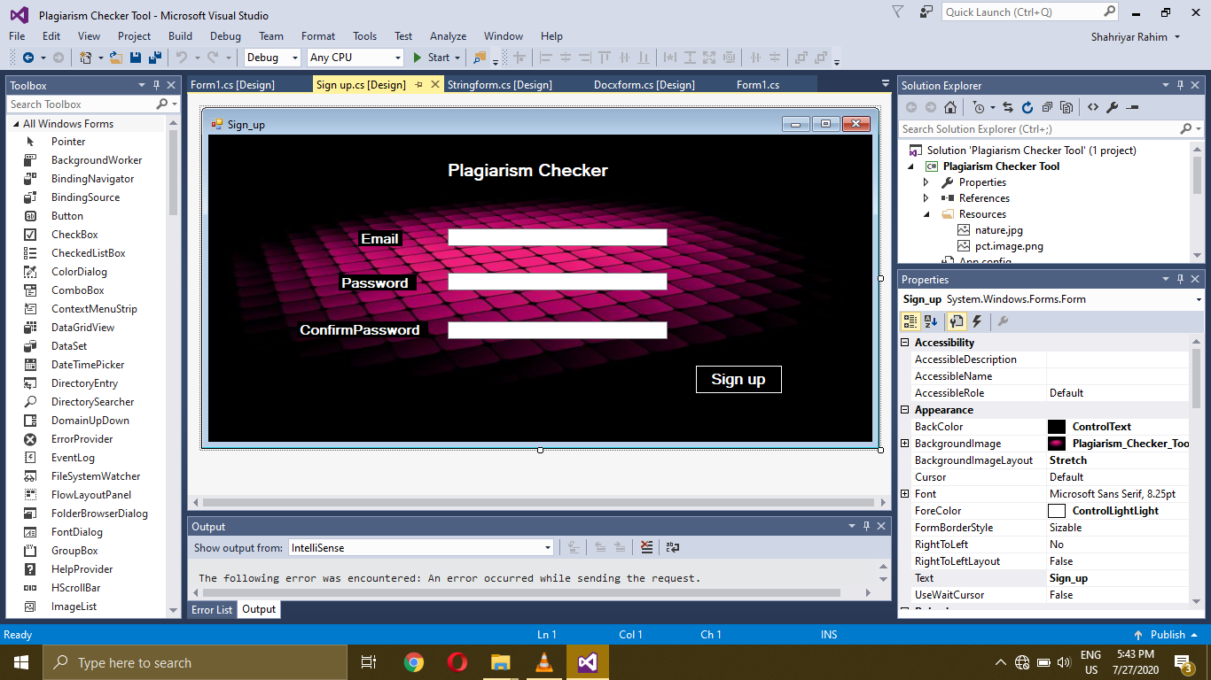

using System;

using System.Collections.Generic;

using System.ComponentModel;

using System.Data;

using System.Drawing;

using System.Linq;

using System.Text;

using System.Threading.Tasks;

using System.Windows.Forms;

namespace Plagiarism_Checker_Tool

{

public partial class Sign_up : Form

{

public Sign_up()

{

InitializeComponent();

}

private void button1_Click(object sender, EventArgs e)

{

this.Hide();

Plagform obj = new Plagform();

obj.Show();

}

}

}

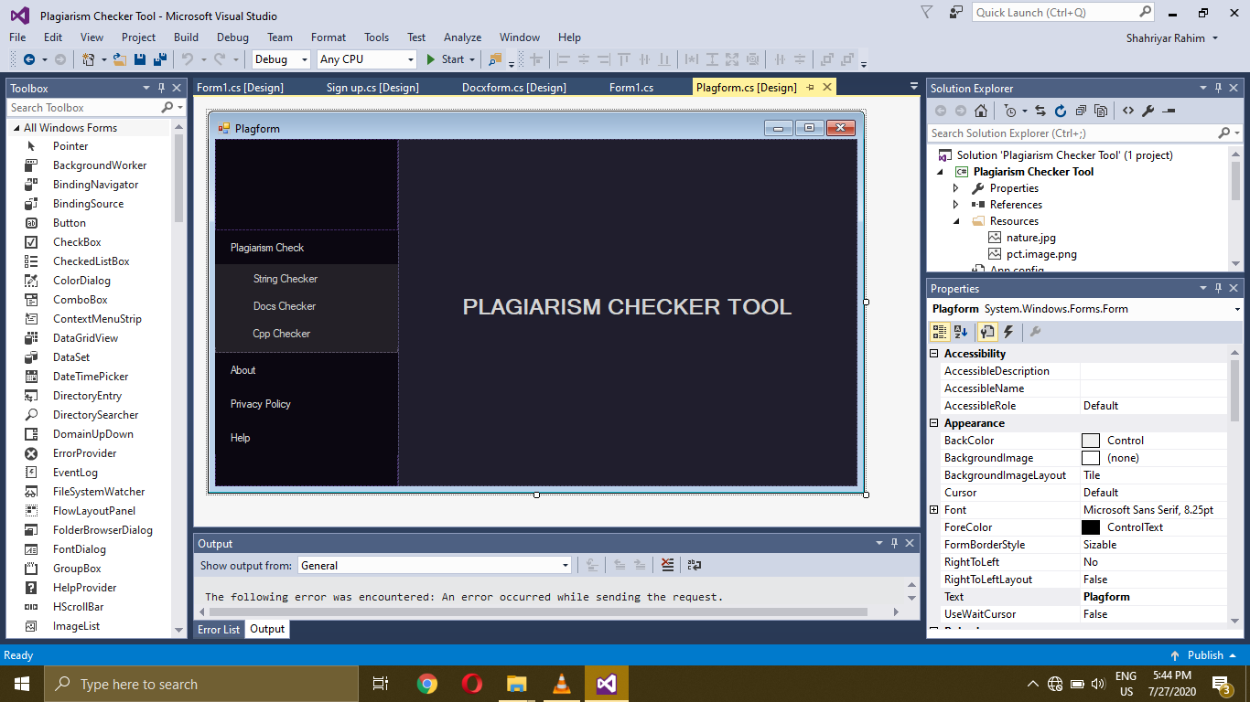

using System;

using System.Collections.Generic;

using System.ComponentModel;

using System.Data;

using System.Drawing;

using System.Linq;

using System.Text;

using System.Threading.Tasks;

using System.Windows.Forms;

namespace Plagiarism_Checker_Tool

{

public partial class Plagform : Form

{

public Plagform()

{

InitializeComponent();

customizeDesign();

}

private void panelSideMenu_Paint(object sender, PaintEventArgs e)

{

}

private void customizeDesign()

{

panelPlagiarismSubMenu.Visible = false;

}

private void hideSubMenu()

{

if (panelPlagiarismSubMenu.Visible == true)

panelPlagiarismSubMenu.Visible = false;

}

private void showSubMenu(Panel subMenu)

{

if (subMenu.Visible == false)

{

hideSubMenu();

subMenu.Visible = true;

}

else

{

subMenu.Visible = false;

}

}

private void btnPlag_Click(object sender, EventArgs e)

{

showSubMenu(panelPlagiarismSubMenu);

}

private void btnString_Click(object sender, EventArgs e)

{

hideSubMenu();

this.Hide();

Stringform obj = new Stringform();

obj.Show();

}

private void btnDoc_Click(object sender, EventArgs e)

{

hideSubMenu();

this.Hide();

Docxform obj = new Docxform();

obj.Show();

}

private void btnCpp_Click(object sender, EventArgs e)

{

hideSubMenu();

this.Hide();

Cppform obj = new Cppform();

obj.Show();

}

private void btnAbout_Click(object sender, EventArgs e)

{

hideSubMenu();

this.Hide();

About obj = new About();

obj.Show();

}

private void btnPrivacy_Click(object sender, EventArgs e)

{

hideSubMenu();

this.Hide();

Privacy_Policy obj = new Privacy_Policy();

obj.Show();

}

private void btnHelp_Click(object sender, EventArgs e)

{

hideSubMenu();

this.Hide();

Help obj = new Help();

obj.Show();

}

}

}

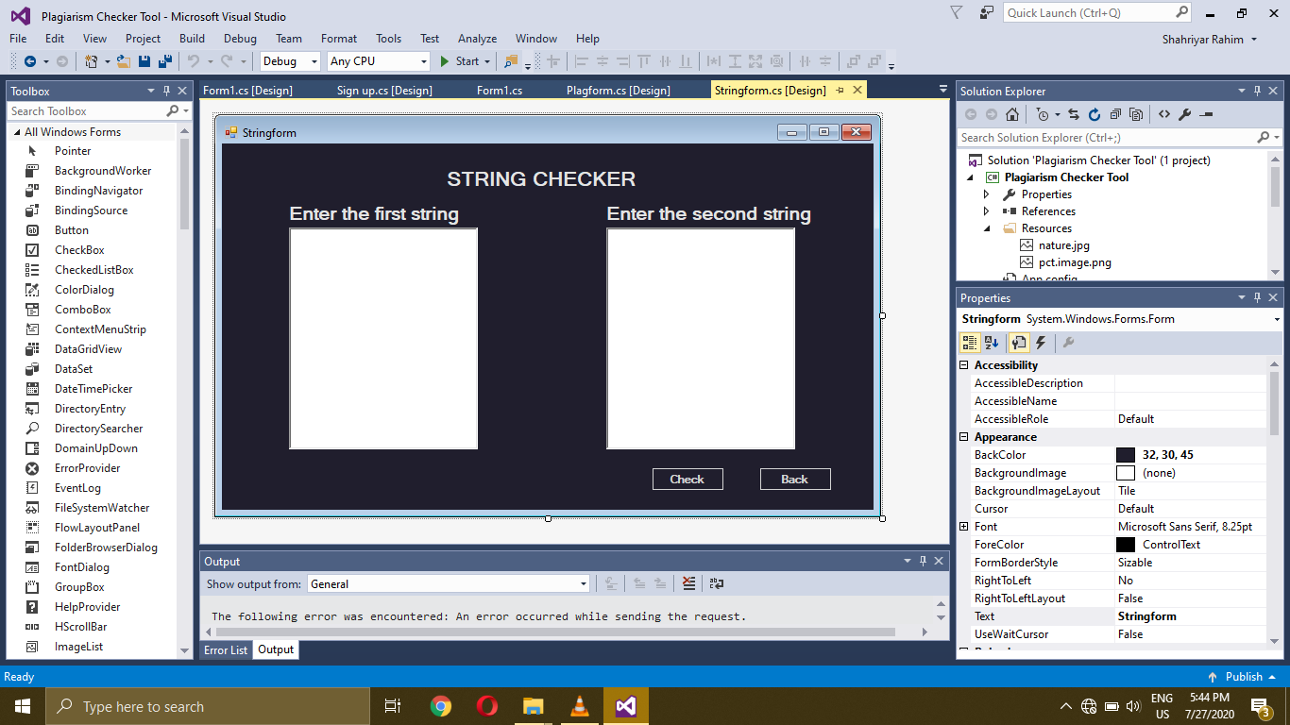

using System;

using System.Collections.Generic;

using System.ComponentModel;

using System.Data;

using System.Drawing;

using System.Linq;

using System.Text;

using System.Threading.Tasks;

using System.Windows.Forms;

namespace Plagiarism_Checker_Tool

{

public partial class Stringform : Form

{

public Stringform()

{

InitializeComponent();

}

private void btnBack_Click(object sender, EventArgs e)

{

this.Hide();

Plagform obj = new Plagform();

obj.Show();

}

}

}

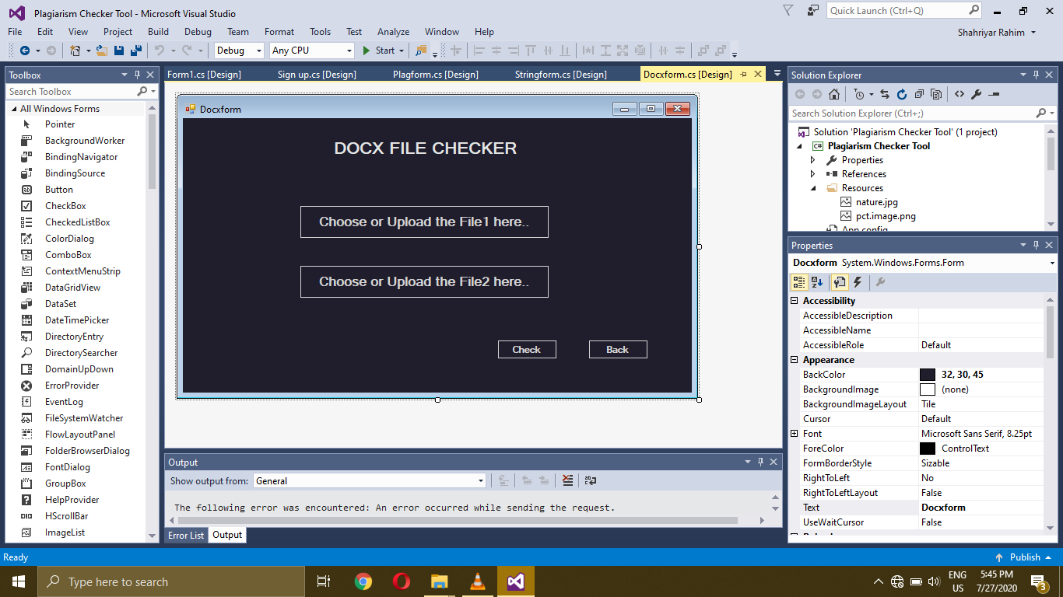

using System;

using System.Collections.Generic;

using System.ComponentModel;

using System.Data;

using System.Drawing;

using System.Linq;

using System.Text;

using System.Threading.Tasks;

using System.Windows.Forms;

namespace Plagiarism_Checker_Tool

{

public partial class Docxform : Form

{

public Docxform()

{

InitializeComponent();

}

private void btnBack_Click(object sender, EventArgs e)

{

this.Hide();

Plagform obj = new Plagform();

obj.Show();

}

}

}

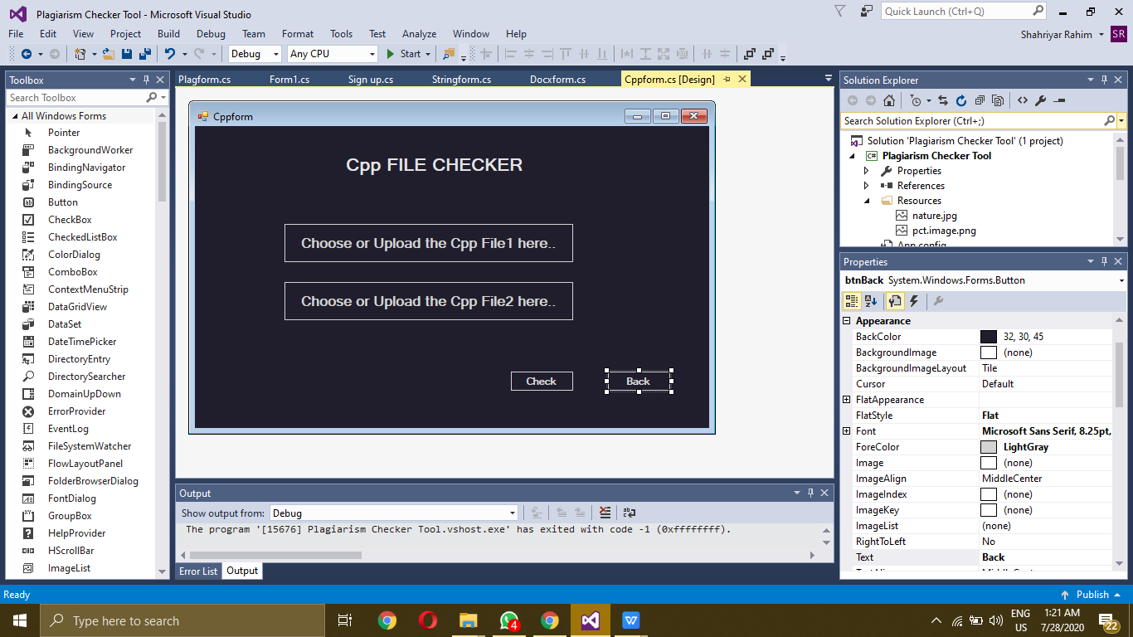

using System;

using System.Collections.Generic;

using System.ComponentModel;

using System.Data;

using System.Drawing;

using System.Linq;

using System.Text;

using System.Threading.Tasks;

using System.Windows.Forms;

namespace Plagiarism_Checker_Tool

{

public partial class Cppform : Form

{

public Cppform()

{

InitializeComponent();

}

private void btnBack_Click(object sender, EventArgs e)

{

this.Hide();

Plagform obj = new Plagform();

obj.Show();

}

}

}

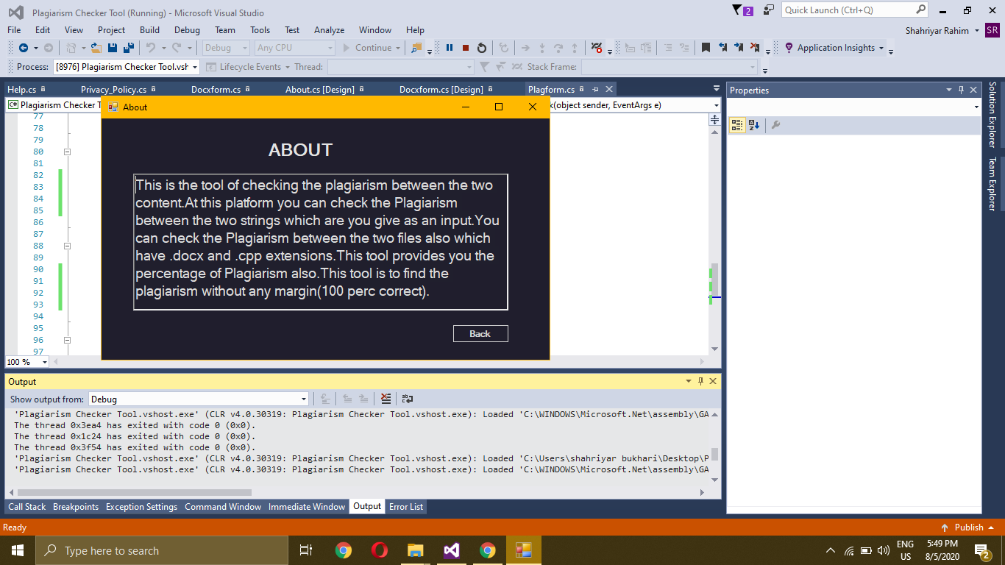

using System;

using System.Collections.Generic;

using System.ComponentModel;

using System.Data;

using System.Drawing;

using System.Linq;

using System.Text;

using System.Threading.Tasks;

using System.Windows.Forms;

namespace Plagiarism_Checker_Tool

{

public partial class About : Form

{

public About()

{

InitializeComponent();

}

private void panel1_Paint(object sender, PaintEventArgs e)

{

}

private void label1_Click(object sender, EventArgs e)

{

}

private void btnBack_Click(object sender, EventArgs e)

{

this.Hide();

Plagform obj = new Plagform();

obj.Show();

}

}

}

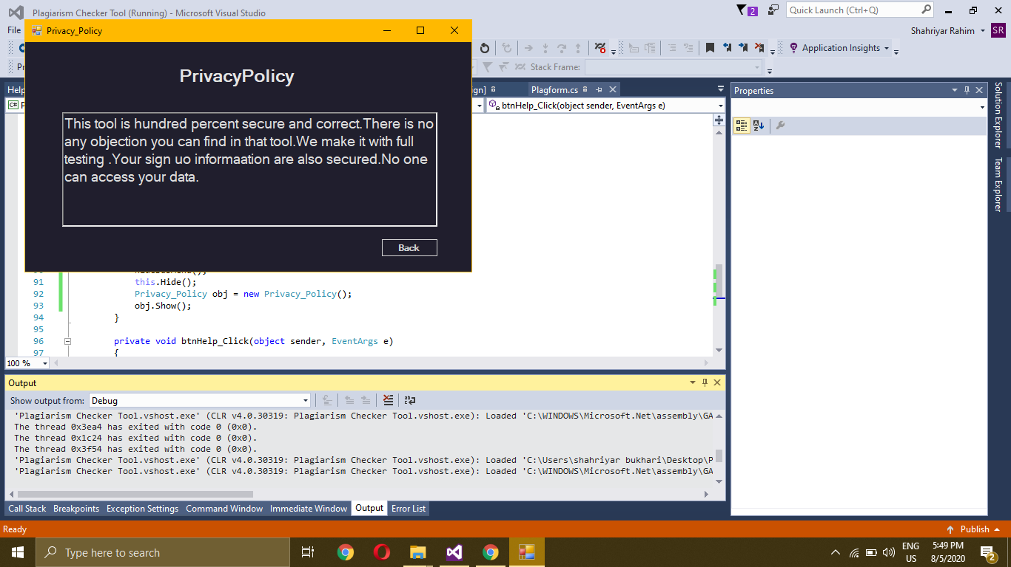

using System;

using System.Collections.Generic;

using System.ComponentModel;

using System.Data;

using System.Drawing;

using System.Linq;

using System.Text;

using System.Threading.Tasks;

using System.Windows.Forms;

namespace Plagiarism_Checker_Tool

{

public partial class Privacy_Policy : Form

{

public Privacy_Policy()

{

InitializeComponent();

}

private void btnBack_Click(object sender, EventArgs e)

{

this.Hide();

Plagform obj = new Plagform();

obj.Show();

}

}

}

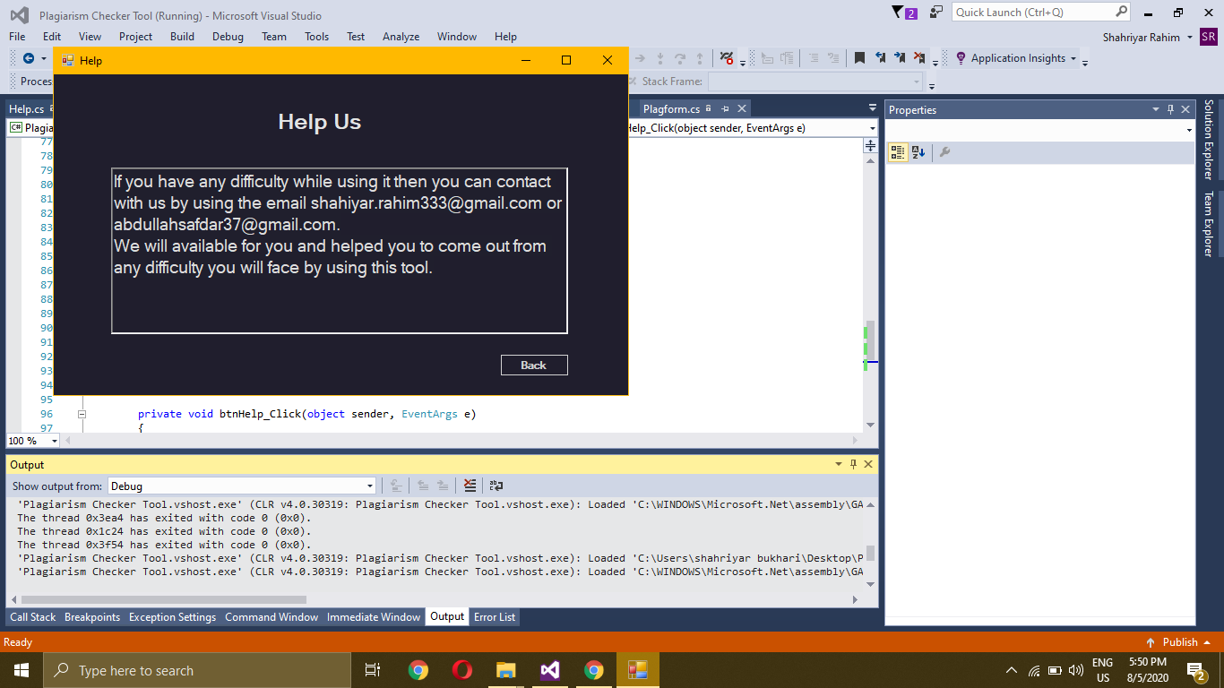

using System;

using System.Collections.Generic;

using System.ComponentModel;

using System.Data;

using System.Drawing;

using System.Linq;

using System.Text;

using System.Threading.Tasks;

using System.Windows.Forms;

namespace Plagiarism_Checker_Tool

{

public partial class Help : Form

{

public Help()

{

InitializeComponent();

}

private void btnBack_Click(object sender, EventArgs e)

{

this.Hide();

Plagform obj = new Plagform();

obj.Show();

}

}

}